Now we will learn about how we can make custom list with the help of map function



As you remember in previous section we made a list with Flatlist component

If you don’t want to use flatlist or default list then How you can do so

For that we need map function it is a javascript function and it is very easy to use Teacher will make us understand in detail

This lesson is important because in Interviews it is often asked to make a list but don’t use any react native feature

There they want to ask your logical mindset that how you will do it in your code

Even if we talk about react native we don’t have any option like flat list In its internal mechanism map function is used to make list So it is very important

Here will be able to understand logic properly that how Flatlist worked internally How it convert an array element into a list So first make an array of user and then with map function we will create a list and apply some style here but now here one more thing is coming here

If there are 1000 element in Flatlist then it make scroll of it

But here whatever item you are seeing are ok but your scroll will not work here so to add scroll there is component called Scrollview that we have to use it

It is very easy to use and at last we will ask some interview question related to map function or list and all some interview question will be discussed related to map function or list and all so we now go on board

We use the array we used in previous lesson

So first we will discuss map function

It basically run a loop inside it like for loop while loop similarly like that ans whatever we write inside the function will be returned that’s why we don’t use while and for loop because we are not returning anything

We can pass the component and applying style here and it will be returned and will be shown in screen

What we are simple going to do is in our return we will use curly bracket to write javascript

So we write as below

  return (

    <>

    <Text style={{fontSize:31}}>

      List with Flat List Component

    </Text>

    {

      users.map((item)=><Text>{item.name}</Text>)

    }

    </>

  );

We will see the output here



We add the style to these item like we added before

return (

    <>

    <Text style={{fontSize:31}}>

      List with Flat List Component

    </Text>

    {

      users.map((item)=><Text style={styles.item}>{item.name}</Text>)

    }

    </>

  );

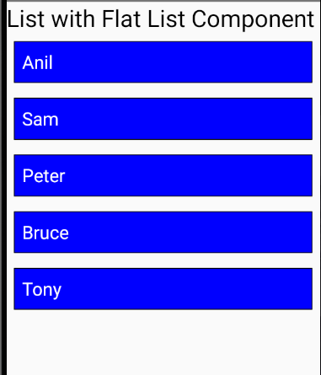

Now suppose we want to increase some element so we add some random object in the array

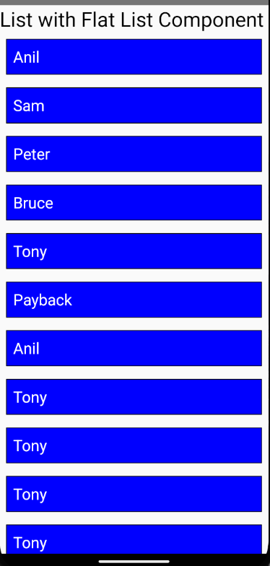

Now you will see the items are going out of the screen and there is no mechanism to see the items below

Lets say I named the last element Kail

Then still above output will be shown

Now if you try to scroll then it will not happen

For that we need to import the component ScrollView from react native

import {Button, Text, View, StyleSheet, TextInput, FlatList,ScrollView} from 'react-native';

Now we will use it as a container tag and this will enclose the map function

Now code will look like below

  return (

    <>

    <Text style={{fontSize:31}}>

      List with Flat List Component

    </Text>

    <ScrollView>

    {

      users.map((item)=><Text style={styles.item}>{item.name}</Text>)

    }

    </ScrollView>

    </>

  );

And the output will contain scrollbar and you can see the last item in the list

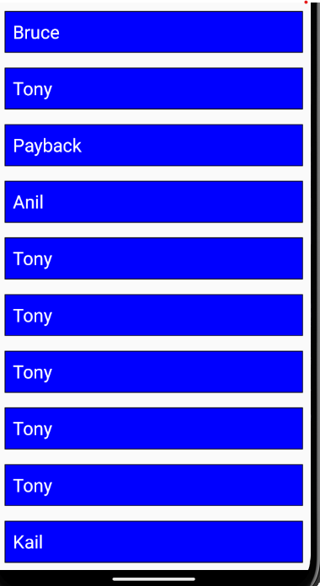

We can add style to our ScrollView and we add marginBottom to it

<ScrollView style={{marginBottom:30}}>

    {

      users.map((item)=><Text style={styles.item}>{item.name}</Text>)

    }

    </ScrollView>

**Output**

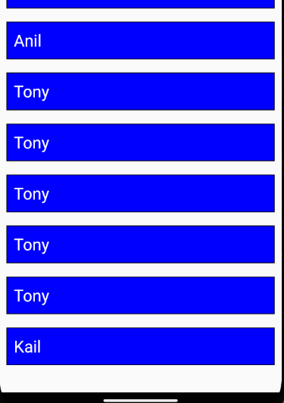

So we can see last and it is scrolling

6:05

So we can see last item and it is being properly scrolled so if you want that then you can make list your self but if it is that easy to make list your self then why they have given flatlist what is its use

It has two or three use because Flatlist has many different features. You can set header and footer of list here which teacher did not tell in last video because It is advance thing in Flatlist we were trying to make basic list . In upcoming part how to set its header and how to set footer. It will be discussed

How to set substractor (who knows) This things will be told by the teacher because as he said there are upcoming lesson on it.

Flatlist has there are huge number of elements like 3000 or 4000 in number not 20,30 or 50 in number

Then flatlist managers it perfectly if there are many elements such that top and bottom elements in the list is removed from UI(maybe they also mean from the memory ) so that your scroll runs smooth .Now suppose you used map function it does not remove anything from the UI(who knows) because it is a core function of javascript(So what) If you have 100 or 150 elements then it will work OK. If your mobile memory or RAM is very less and list id 3000 or 4000 elements then the problem you will face when you scroll something then it start getting hanged then in that case Flatlist performs better and there are also other uses With Flatlist you can do lazy loading which can be difficult for map and you have to use many logic(who knows)but again if the custom logic are asked of you in Interview then you can do so

I interview you could be asked to make a list with map function or make custom list without flat list that‘s you have seen

Secomd they can ask you if you have made list then what ius the difference between custom list by map and flat list As the teacher has told there will be performance issues and there will be many issues with scrolling (who knows)

If you want to tell about benefit then you can tell that if you are sure before hand that there are only 40 – 50 elements and more element will not come so Here you get many things you can do style here It is your loop and when we have very less element you have to export less element (who knows maybe by return) otherwise you need to give many properties when there are many features then it gets heavier for large list it is good but if there is small list then why we even use a Component for it we will write our core code

Inside the Flatlist there must be a function used here or similar function will be used here for looping.

But on it they add many features that’s why it become vast